***TOPIC:***

***SENSOR STATION:***

***MEASURING AIR QUALITY INDEX***

***Made By:***

***Ishani Sharma(2101AI16) & Pragya Harsh(2101AI23)***

***Submission Date: 02/12/2022***

***Motivation:***

***About Air Pollution:***

*Air pollution has become a common phenomenon everywhere. Specially in the urban areas, air pollution is a real-life problem. A lot of people get sick only due to air pollution. In the urban areas, the increased number of petrol and diesel vehicles and the presence of industrial areas at the outskirts of the major cities are the main causes of air pollution. The problem is seriously intensified in the metropolitan cities. Also, the climate change is now apparent. The governments all around the world are taking every measure in their capacity. Many European countries have aimed to replace petrol and diesel vehicles with the electric vehicles by 2030. Even India has aimed to do so by 2025. The use of coal for electricity generation is now going to be a thing of past. The nations are now focusing to generate energy from nuclear reactors and the renewable resources like solar energy, wind energy and hydroelectric power.*

***About Project:***

*It is now important to monitor air pollution in real time in most of the urban areas.*

*This project is aimed at developing an IOT device which can monitor air pollution in real time and log data to a remote server. Remote monitoring was facilitated using classical modes in the past, which has some pitfalls like limited memory, processing speed and complex programming strategies. By using Internet of Things and recording sensor data to a remote server, the limitations of memory in the monitoring devices and manual collection of data from the installed devices can be overcome. The IOT also helps monitoring the data in real time.*

***Introduction:***

*Now, in our project, we have tried to build a model that could help in minimizing one of the most challenging issues of air pollution.*

*The air pollution monitoring device developed in this project is based on Arduino UNO, which connects to the ThingSpeak App using the Wi-Fi Module. The sensor used for monitoring air pollution is the MQ-135 gas sensor. In this project, we have also integrated a DHT11 Temperature and Humidity Sensor. The sensor data is also displayed on the serial monitor interfaced with the monitoring IoT device.*

***Description:***

*In our project, the Arduino Board connects to the ThingSpeak App using the ESP8266 Wifi Module. As the cities usually have Wi-Fi hotspots at most of the places, so the device can be easily installed near any hotspot for its operation. The ThingSpeak is a popular IOT platform.*

*The MQ-135 gas sensor monitors the level of gases like Carbon dioxide, Carbon monoxide, Ammonia, Acetone, Toulene, Sulphide which major contributers to air pollution.*

*The DHT11 Temperature and humidity sensor measures the temperature and humidity of the environment.*

*Monitoring temperature along with the major polluting gases could also help in investigating about global warming, another major environmental problem of the era.*

*Thus, the sending the sensed data to the ThingSpeak server using the Wi-Fi module is managed by the Arduino Sketch.*

*The ThingSpeak App helps in analysing the sensed data in various different ways, like plotting the data set in the form of a graph that makes the information more illustrative. The Arduino sketch is written, compiled, and loaded to the Arduino board using Arduino IDE.*

***COMPONENTS REQUIRED:***

1. ***ARDUINO UNO:***

*Arduino UNO is one of the most popular prototyping boards. It is small in size and packed with rich features. The board comes with built-in Arduino boot loader. It is an Atmega 328 based controller board which has 14 GPIO pins, 6 PWM pins, 6 Analog inputs and on board UART, SPI and TWI interfaces. In this IOT device, 9 pins of the board are utilized. There are six pins used to interface the character LCD. There are two pins utilized to interface the ESP8266 Wi-Fi Module and an analog input pin is used to connect with the MQ-135 sensor*

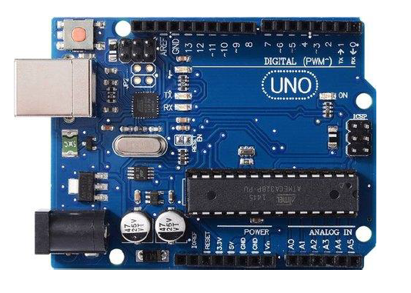

1. ***NodMCU ESP8266 Wi-Fi Module:***

*The ESP8266 Wi-Fi Module is used to connect with any available internet hotspot and transfer sensor data to ThingSpeak Platform via Wi-Fi. The ESP8266 Wi-Fi Module is a self contained SOC with integrated TCP/IP protocol stack that can give any microcontroller access to a Wi-Fi network.* *The ESP8266 is capable of either hosting an application or off loading all Wi-Fi networking functions from another application processor. Each ESP8266 module comes pre-programmed with an AT command set firmware.  So, one can simply hook this up to an Arduino device. Here it uploads the monitoring data to the cloud. The module comes available in two models – ESP-01 and ESP-12. ESP-12 has 16 pins available for interfacing while ESP-01 has only 8 pins available for use.*

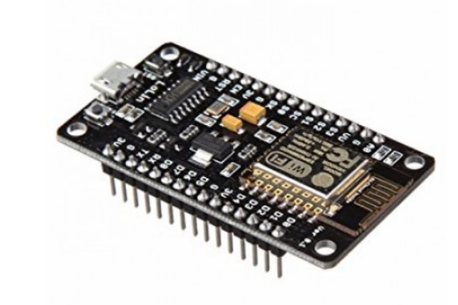

1. ***MQ-135 Sensor:***

*MQ-135 is a gas sensor which is used to measure the concentration of combustible gases. It has lower conductivity in clean air while its*

*conductivity increases with the presence of the combustible gases in the air.*

*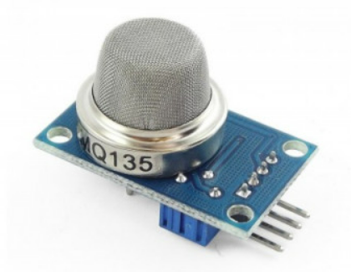The sensor is highly sensitive to gases like Ammonia, Sulphide and Benzene steam. The sensor can detect the concentration of combustible gases in range from 100 PPM to 1000 PPM.*

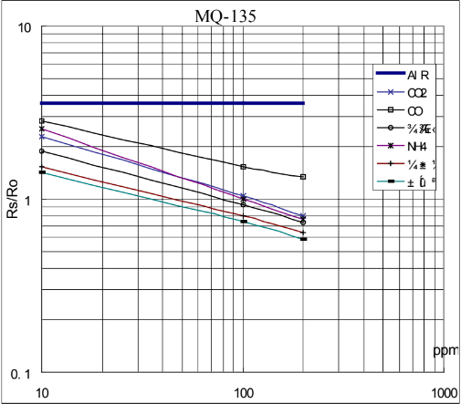

***Sensitivity characteristics of the MQ-135 for several gases.***

***Temp: 20 degrees celcius***

***Humidity: 65%***

***O2 concentration 21%***

***RL=20kΩ***

***Ro: sensor resistance at 100ppm of***

***NH3 in the clean air.***

***Rs: sensor resistance at various concentrations of gases.***

*From the sensitivity curve of the sensor, it can be seen that the resistance of the sensor decreases as the concentration of the target gas is increased in PPM while for clean air its resistance remains constant. In the graph, the Rs is the resistance in target gas and Ro is the resistance in clean air. The graph is shown for Carbon dioxide, Carbon Monoxide and Ammonia. The sensitivity of this sensor can be adjusted and calibrated to detect specific concentration level of a target gas. The sensor has four terminals – Ground, VCC, Digital Out and Analog Out. The VCC and Ground terminals of the sensor are connected to the common VCC and Ground. The Analog Output pin of the sensor is connected to the A0 pin of the Arduino. The analog output voltage from the sensor can be assumed directly proportional to the concentration of CO2 gas in PPM under standard conditions. The analog voltage is sensed from the sensor and converted to a digital value in range from 0 to 1023 by the inbuilt ADC channel of the controller. The digitized value is hence equal to the gas concentration in PPM.*

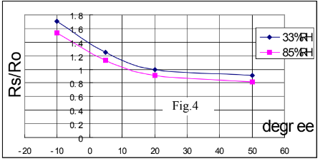

***Ro: sensor resistance at 100ppm of NH3 in air***

***at 33%RH and 20 degrees .***

***Rs: sensor resistance at 100ppm of NH3***

***at different temperatures and humidity.***

***Dependence of the MQ-135 on temperature and humidity.***

1. ***DHT11 Sensor:***

***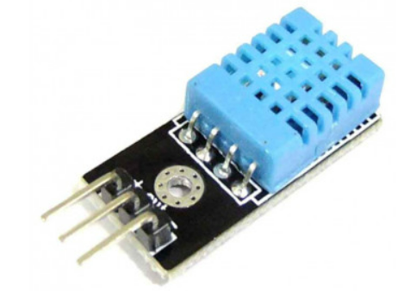****The DHT-11 Digital Temperature and Humidity Sensor is a basic, low-cost digital temperature and humidity sensor. It uses a capacitive humidity sensor and a thermistor to measure the surrounding air and spits out a digital signal on the data pin (no analog input pins needed).*

1. ***Breadboard****:*

*A breadboard is a solder less rectangular plastic board*

*with a bunch of tiny holes in it. These holes let us easily insert electronic components to prototype an electronic circuit.*

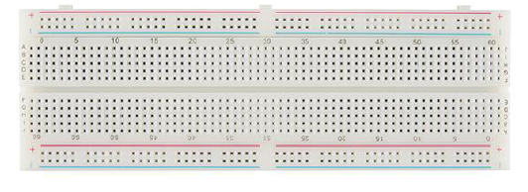

1. 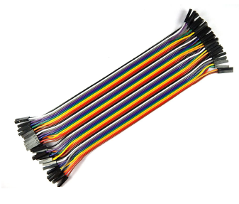***Jumper Wires***

***APPLICATIONS USED:***

* ***ThingSpeak :***

*ThingSpeak is an IoT analytics platform service that allows you to aggregate, visualize, and analyze live data streams in the cloud. You can send data to ThingSpeak from your devices, create instant visualization of live data, and send alerts.*

*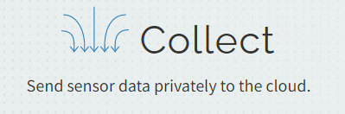*******

* ***Arduino IDE :***



*The Arduino Integrated Development Environment – or*

*Arduino Software (IDE) - contains a text editor for writing code, a*

*message area, a text console, a toolbar with buttons for common*

*functions and a series of menus. It connects to the Arduino hardware to upload programs and communicate with them.*

**FULL CIRCUIT IMAGES:**

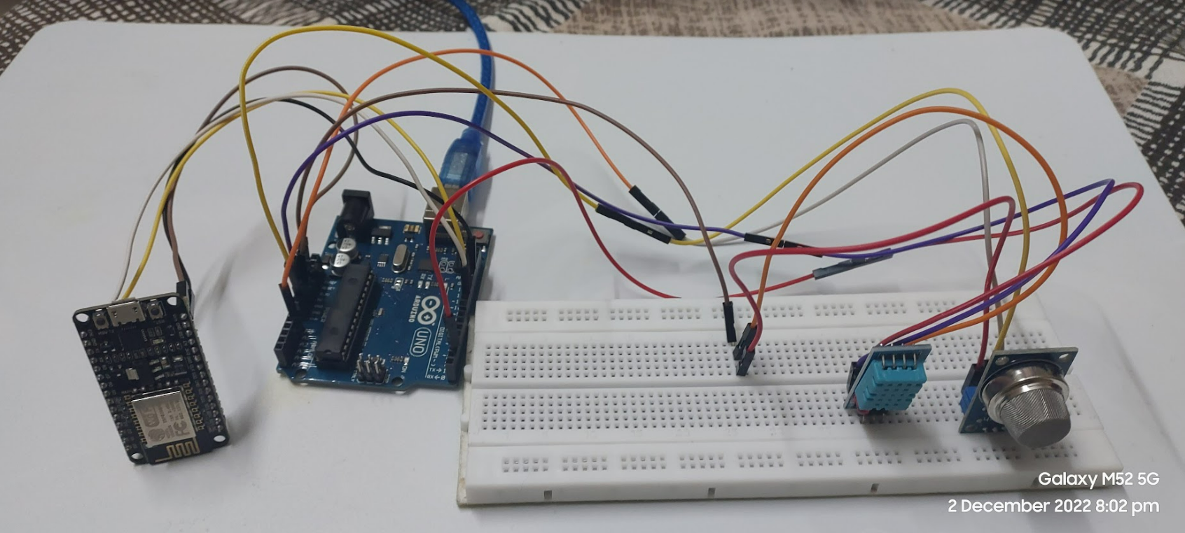

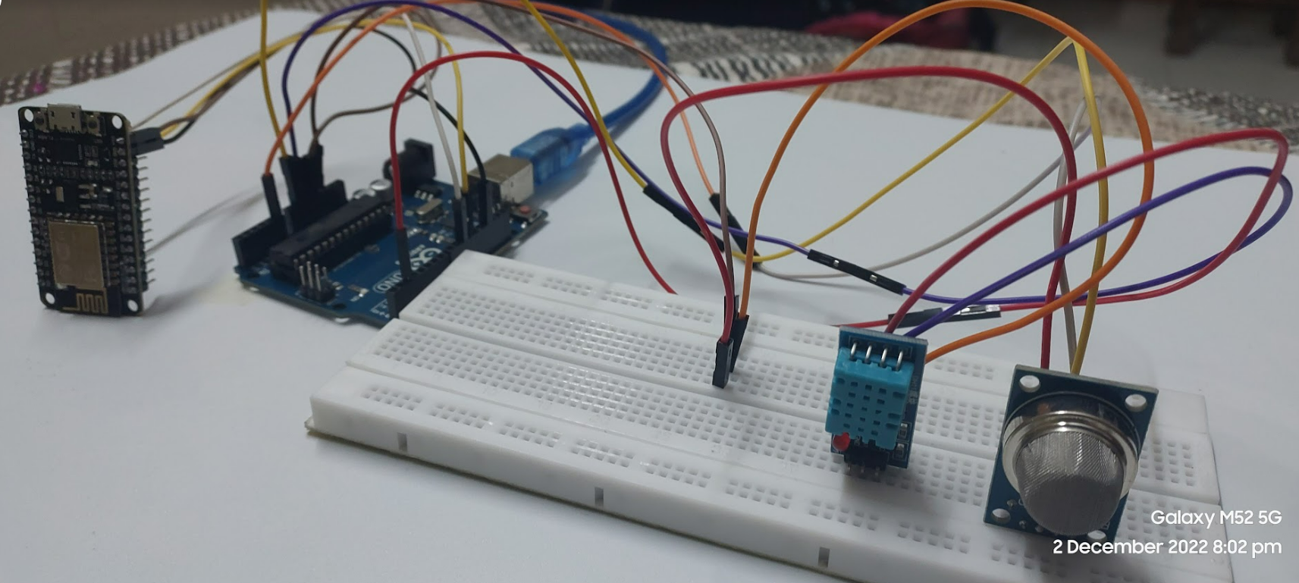

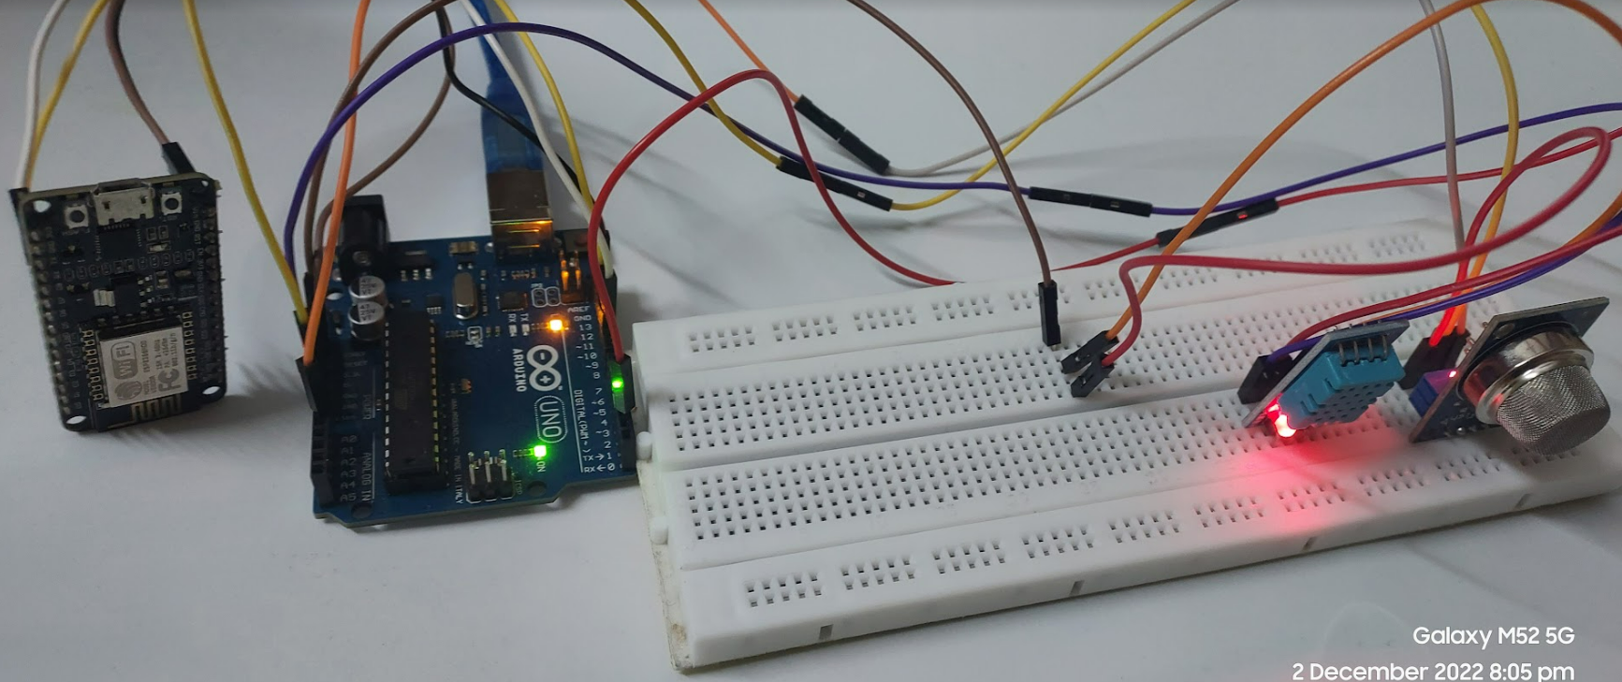

**CONNECTION DESCRIPTION:**

1. 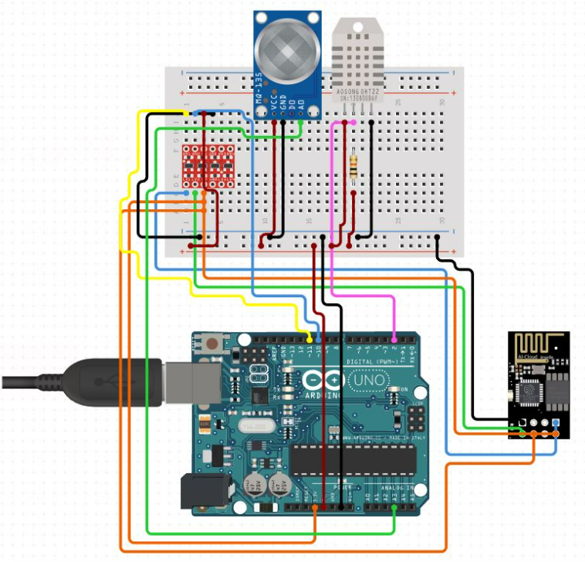**NodeMCU Esp8266**

TX - 10

RX - 11

Vin - 5v

Gnd - gnd

1. **DHT11**

Vcc - 3.3v

Data - 2

Gnd - gnd

1. **MQ135**

A0 - A0

Vcc - 3.3v

Gnd – gnd

***Working Flow:***

*The device developed in this project can be installed near any Wi-Fi hotspot in a populated urban area. As the device is powered, the Arduino board loads the required libraries, flashes some initial messages on the serial monitor and starts sensing data from the MQ-135 sensor and DHT11 sensor. The sensitivity curve of the gas sensor for different combustible gases is already mentioned above. The sensor can be calibrated so that its analog output voltage is proportional to the concentration of polluting gases in PPM. The analog voltage sensed at the pin of the Arduino is converted to a digital value by using the in-built ADC channel of the Arduino. The Arduino board has 10-bit ADC channels, so the digitized value ranges from 0 to 1023. The digitized value can be assumed proportional to the concentration of gases in PPM. The read value of the Total AQI is first displayed on serial monitor and passed to the ESP8266 module wrapped in proper string through virtual serial function.  The Wi-Fi module is configured to connect with the ThingSpeak IOT platform. ThingSpeak is an IOT analytics platform service that allows to aggregate, visualize and analyze live data streams in the cloud. ThingSpeak provides instant visualizations of data posted by the IOT devices to ThingSpeak server.*

***Plots of the Data sensed by the MQ135 and DHT11 sensor as analysed by the ThingSpeak server***

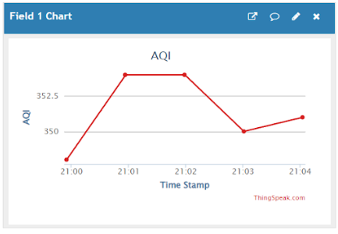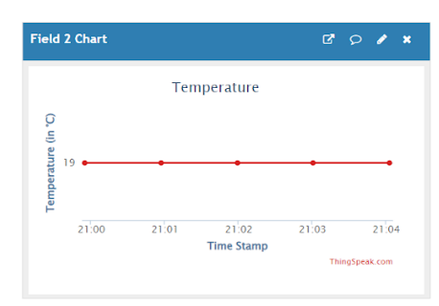

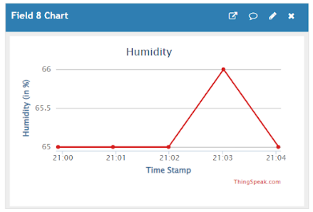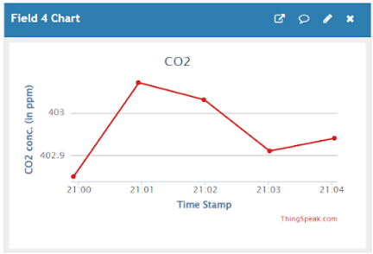

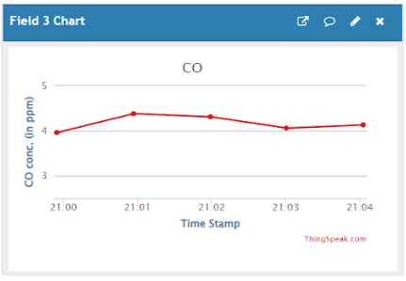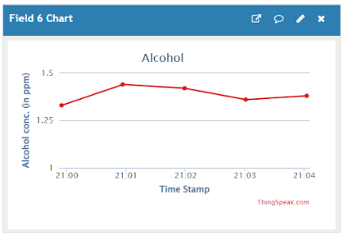

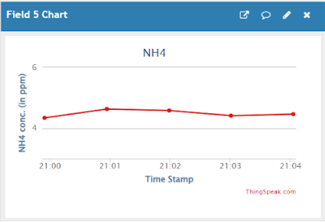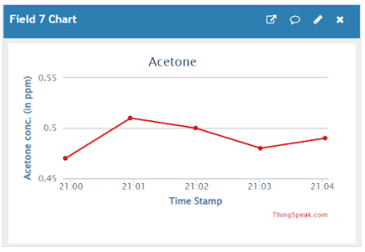

*(Data used for the plots is of South-West Delhi as of 1st December 2022 at 9 pm)*

